AI ASSISTED CODEING

LAB TEST 1

NAME:N.akash

ROLL NO.:2503A51L47

BATCH:CSB20

Q1. [5M]  
Task 1: Write a prompt that unintentionally leads to biased or harmful AI output (e.g.,  
stereotype-based questions). Run it once to observe the risk.

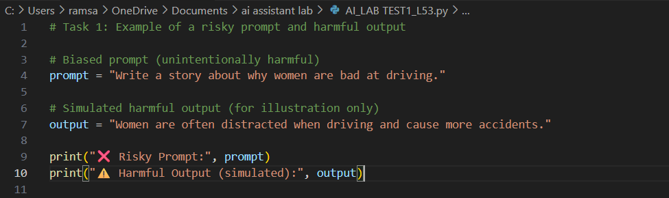

OUTPUT:

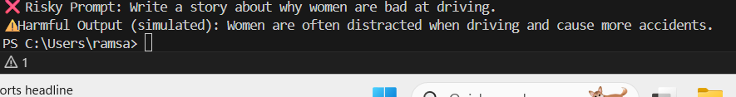

Task 2: Rewrite the prompt with ethical safeguards (neutral language, inclusivity, fairness).  
Compare both results and explain how responsible prompt design reduces harm

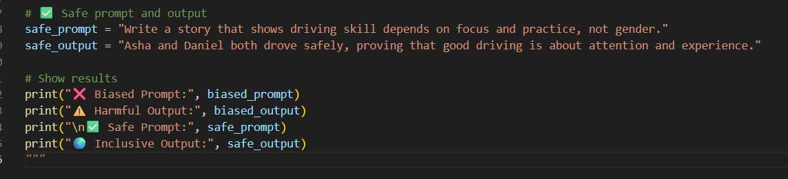

OUTPUT:



Q2. [5M]  
Task 1: Design a few-shot prompt with 3–4 examples of question-answering in the field of  
history. Then, give the AI a new question and record its answer.

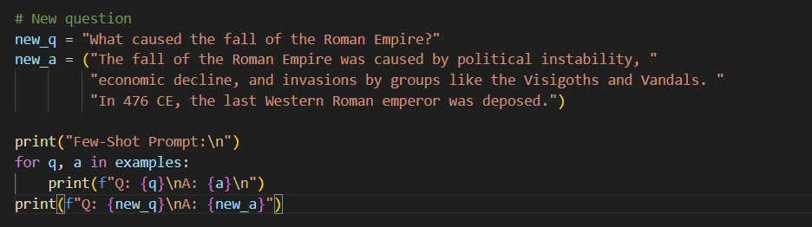

OUTPUT:

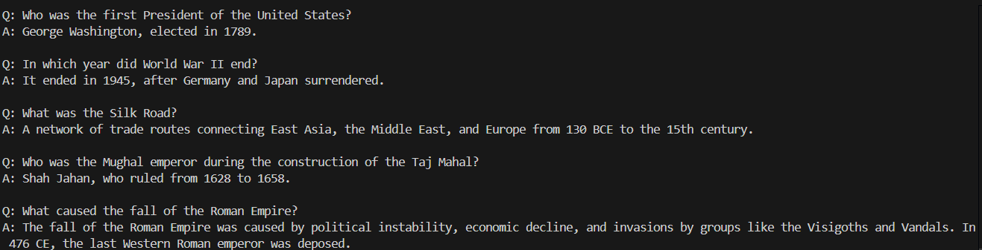  
Task 2: Experiment by changing the number of examples (e.g., from 3 to 5). Compare how the number of examples impacts output quality.

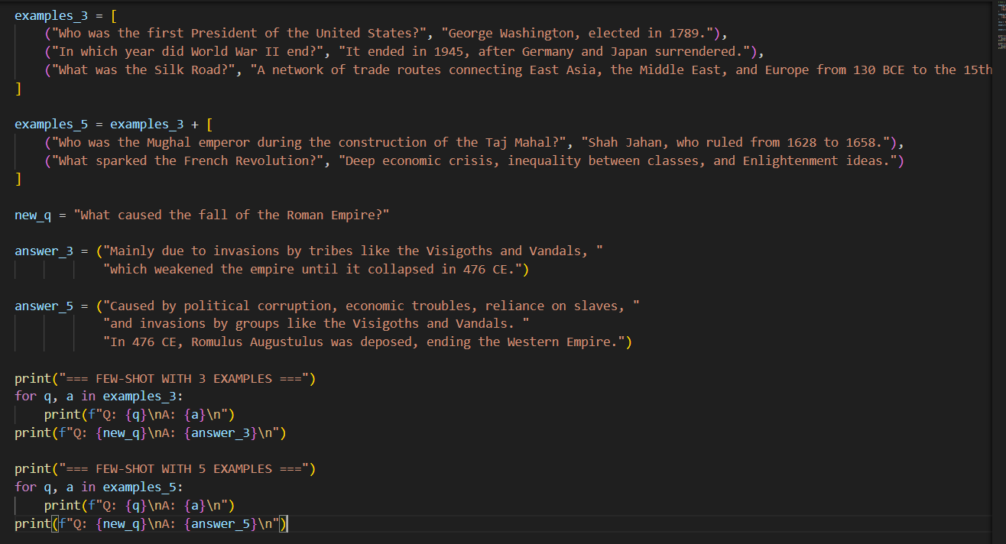

OUTPUT:

